HAPPY VALLEY PRIMARY SCHOOL NEWSLETTER

29th August

Respect Responsibility Integrity

Lesia & Miss Vanessa’s Year 1 and 2’s

2nd September
SCHOOL CLOSURE DAY

3rd September
Grounds Committee Meeting

4 September
Principal Tour
9:30 – 10:30am
SAPSASA Netball

5th September
Garden Market

9th September
Principal Tours
6:00 – 7:00pm
Governing Council Meeting

11-13th September
Year 6 Camp to Monarto Zoo
Room 1 Dr Suess Superstars
Our Class Motto:
Today is your day
Your mountain is waiting,
So, get on your way
Dr Suess

Term 3 has been reading busy, hairlarious and out of this world!
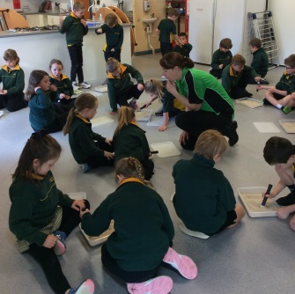
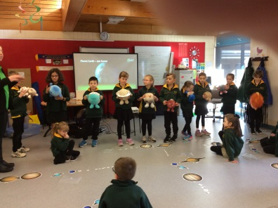
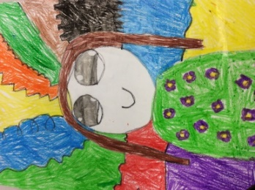
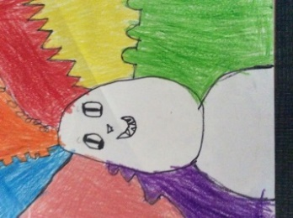

HairLine Artwork

Introduction to Astronomy Science Week

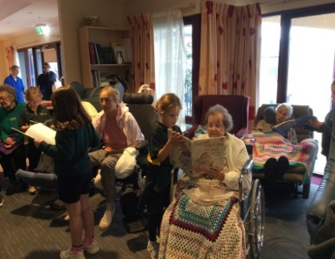
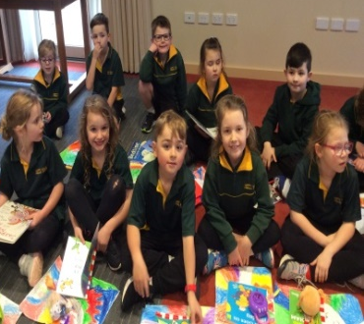
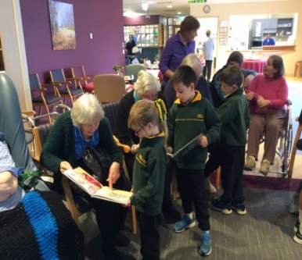
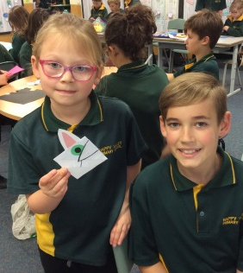

Bethsalem
Visit
Book Week
Bookmarks
With Our Buddies

Coming Soon - Sports Day Photos
to the gallery on the school website www.happyvalley.sa.edu.au

PRINCIPAL’S REPORT

I would like to wish Sue Schmidt well as she begins her Long Service Leave for the remainder of the term. Sue and I have been working very closely together this year and, consequently, I feel confident that I will be able to maintain our fantastic momentum over the next five weeks with the support of all our amazing staff. I am excited to be working alongside Anthea Bartlett who is our Acting Deputy Principal.
Book Week
Our Book Week celebrations went exceptionally well last week with Robyn and our Book Week task group organising excellent activities. Our cartoonist, Brodie from Toonworld made all of the students smile as he talked about his illustrations and allowed them to experiment with cartooning. It was great to see so many amazing costumes and hear about our Superhero winners at the parade, watched on by lots of parents and families. Please visit our school blog for lots of photos and more information: http://happyvalleyprimary.edublogs.org/.
ICAS
The ICAS Assessments are designed to assess your child's ability to apply classroom learning in new contexts, using higher-order thinking and problem-solving skills. These optional tests take place annually in the subject areas of digital technologies, science, writing, spelling, English and mathematics and will take place over the first two weeks of September for those families who have already paid and entered their child. Good luck everyone!
PAT M/R
Progressive Achievement Tests (PAT) are used in thousands of schools in Australia and around the world. The approach focuses on assessing and monitoring student growth over time and is underpinned by an understanding that students of the same age and in the same year of school can be at very different points in their learning and development. The whole focus is around a growth mindset – tailoring teaching to the needs of the individual learner to advance the progress of every student, regardless of their starting point. These mathematics and reading assessments will happen for students in Year 3 and upwards throughout week 7, 3rd to 6th September.
Interoception Room
Interoceptive awareness can be broadly defined as the conscious perception of an internal bodily state, for example, one’s heart beating and breathing. These senses are related to emotional experiences.
Benefits of teaching interoception:
• To help children/students connect to and learn to understand their own bodies and emotions.
• It is a pre‐requisite skill for self‐management and self‐regulation. It provides children/students with the tools to know when they are developing emotional reactions and the skills to be in control of those reactions.
• Without interoception, social skills are just the application of rules and not a meaningful way of interacting – it enables students to develop a sense of belonging.
• Classrooms where interoception is being taught have decreasing behavioural challenges over the school year and those where it is not have static or increasing behavioural challenges.
Towards the end of last term, we were lucky enough to win an Interoception Grant for our school. This will be used to set up a sensory room as well as purchase resources for our classroom spaces. All staff had some training this week during staff meeting and will embed these strategies into their classroom spaces.
Pupil Free Day
On our upcoming Pupil Free Day on Friday 30th August, all of our staff will be attending school to develop themselves within three engaging sessions: Building our Understanding of the Big 6 Literacy Principles (with Jackie Morgan), Using Learning Intentions and Success Criteria to Move Learning Forward (with Dana Lauck) and finally Shifting from Engagement to Empowerment (with Lyn Ferenci). Our SSO’s are attending a tailor made session around Understanding Autism Spectrum Disorder with our Special Educator Puneet Gill. We are all looking forward to this productive day and sharing our new learning with you.
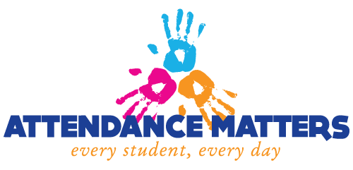

Congratulations we hit
96%
attendance this week.

ASSEMBLY AWARDS presented 29/8/19
At each assembly, a ‘Powerful Learner Award’ is presented to two students from each class. These awards are presented to students that have displayed outstanding attitude towards their schooling within varies aspects.
Mrs Bartlett: Tiah B & Max M Georgia: Matilda P & Owen B
Lesia: Emma R & Rhys B Mrs James: Milla W & James D
Mrs Loveday: Ella T & James M Prue & Mrs Rawling: Alana M, Lachlan W & Dakota Z
Miss Viki: Mikayla L & Cooper C Miss Tilling: Neive M & Kaitlin M
Miss Bosworth: Kade B & Tyler J Mrs Liscombe: Mya M & Kris G
Mrs Lane: Addisyn M & Lachlan B

SCARECROWS FOR ROYAL ADELAIDE SHOW
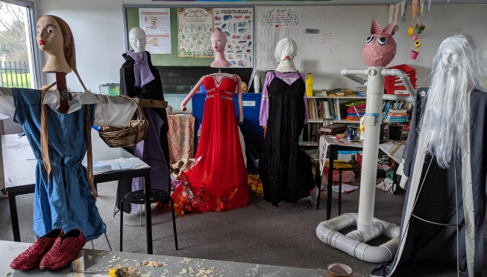
A group of our year 6 and 7 have spent many of their lunch time hours building 7 Scarecrows to be entered in this year's Royal Adelaide Show. The students all decided on a Storybook theme and their choice showed how stories have developed for older readers over the last few years.
Your time and hard work shows in the results, good luck!
Please visit our school blog for lots of photos and more information: http://happyvalleyprimary.edublogs.org/.
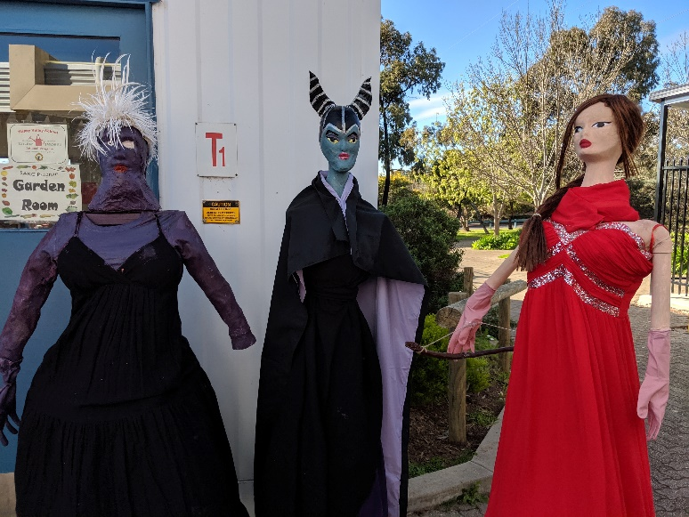
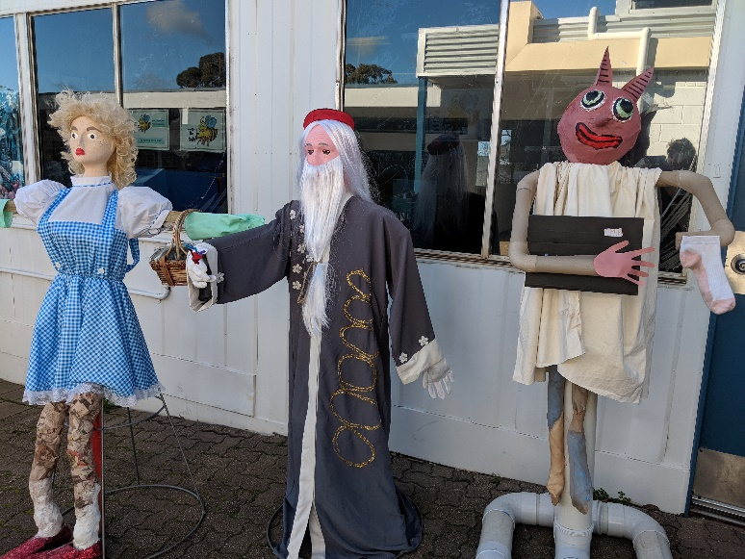

Happy Valley Primary School
18 Education Road
Happy Valley SA 5159
Phone 08 8381 7166
Email dl.0171.info@schools.sa.edu.au

